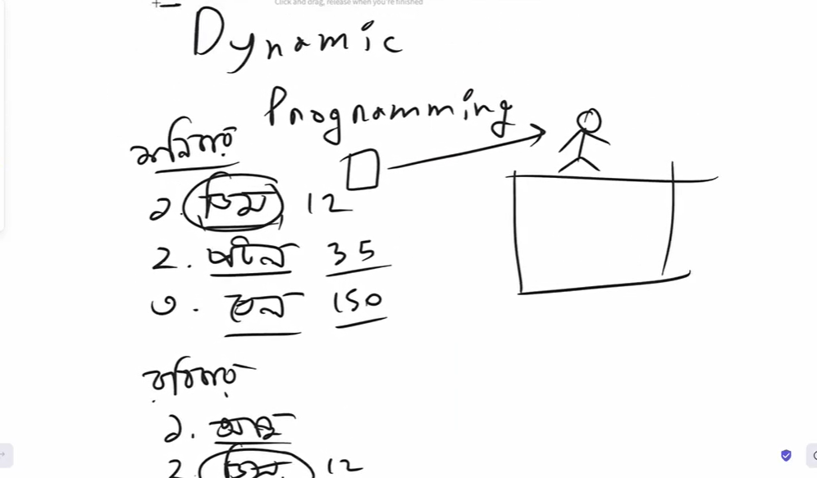

Here we stored eggs price a day before, we don’t need to know again eggs price at Sunday.

When it needs we get the actual value of eggs, we don’t need to recall the eggs function.

That’s the concept of dynamic programming, shortly – Store and reuse.

**Note : eki calculation ekbar er beshi korbo na**

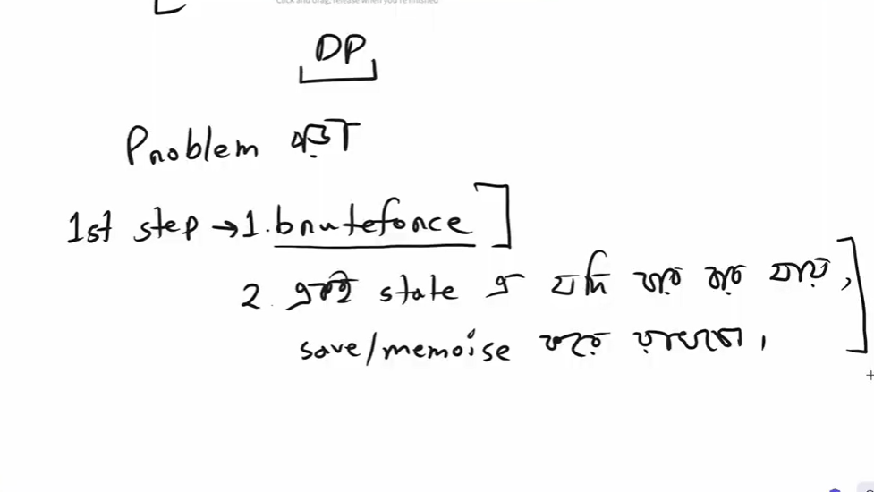

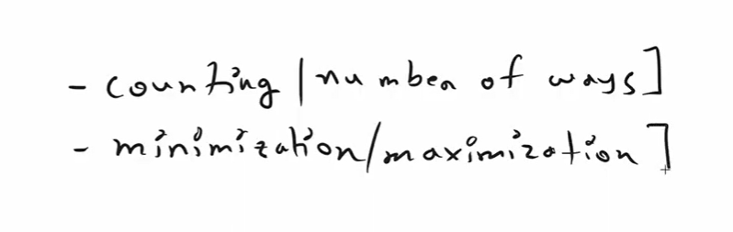

**Problem:** [**https://cses.fi/problemset/task/1633**](https://cses.fi/problemset/task/1633)

**Solution:**

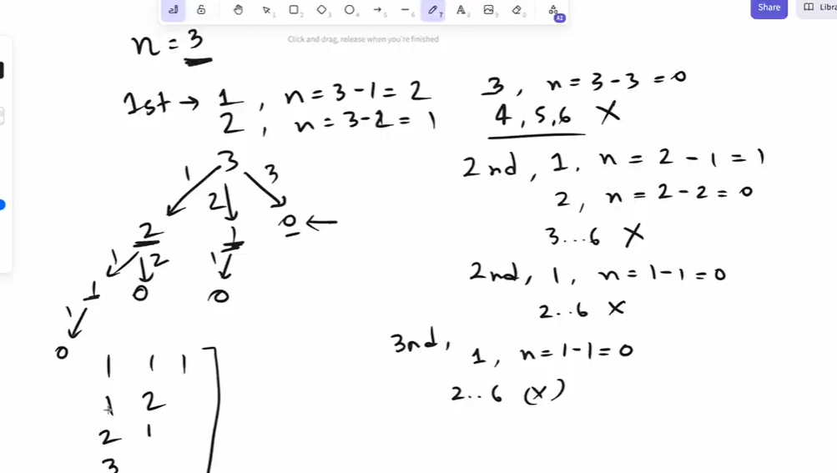

**Example:**

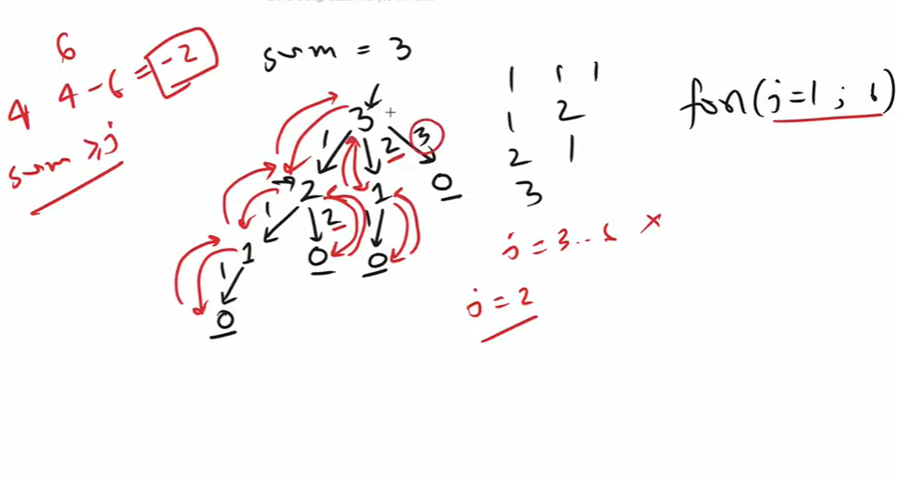

**Bruteforce:**

